

| **TITLE:** **Design the static web pages with the help of HTML5** |
| --- |

**AIM:** To create static Web Pages using HTML5.

**______________________________________________________________________**

**Expected Outcome of Experiment:** Design static web pages using various HTML tags.

**_______________________________________________________________**

**Books/ Journals/ Websites referred:**

**_____________________________________________________________________**

The students are required to design Web Application using various technologies. A group of 2-3 students will select a topic and will design a web application. Various concepts such as static page, dynamic page, connection with a backend database are essential part of the application.

Students will be required to mention an overall description of the problem (website facilities) to be provided by their application.

**Problem Statement:**

**<** Explain in words what facilities / functionalities your application is expected to support>

The project’s primary goal is to give the student’s exam results in a quick and understandable manner. Students and universities can benefit from this project by receiving results in an easy-to-understand manner. The student is the system’s intended user, and students are given the ability to read and execute their results by entering login details. For brand-new students, registration is also an option. The guest user is viewing.

**Description of the application implemented with output**:

< Add screen shots of the pages here>

# 

# 

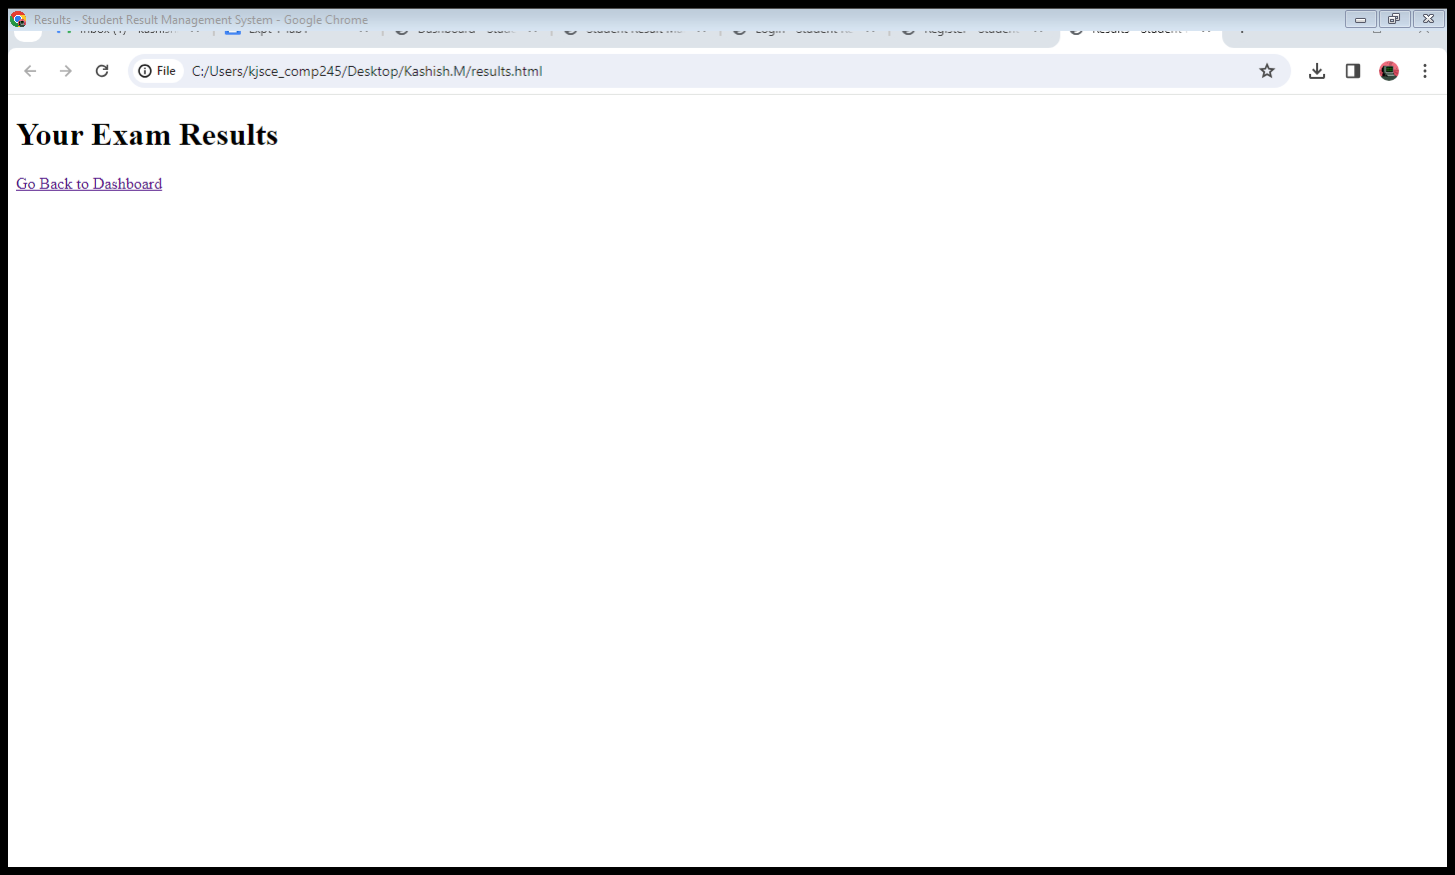

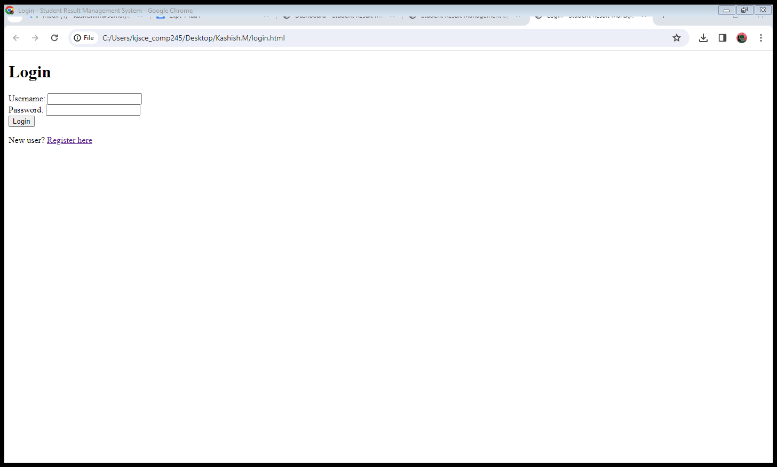

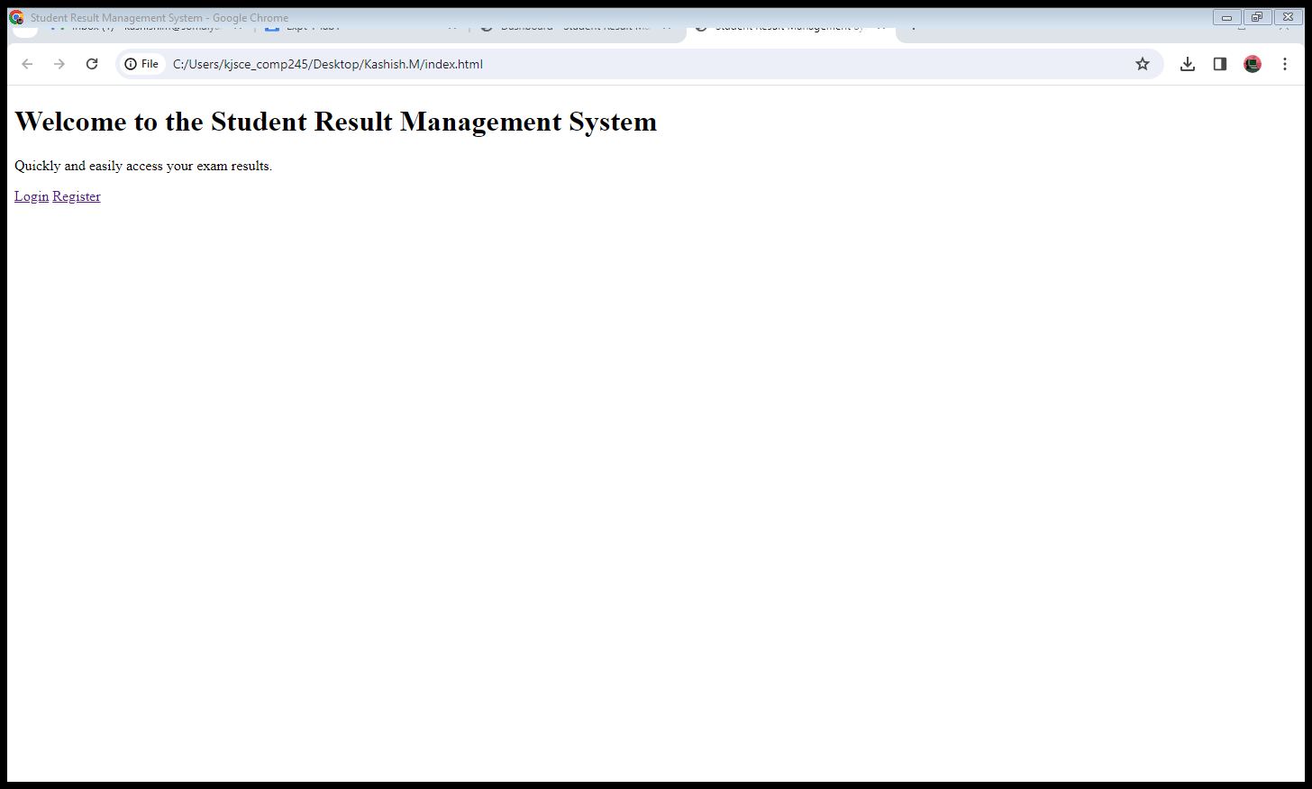

**Code:**

**Dashboard.html**

<!DOCTYPE html>

<html lang="en">

<head>

<meta charset="UTF-8">

<meta name="viewport" content="width=device-width, initial-scale=1.0">

<title>Dashboard - Student Result Management System</title>

</head>

<body>

<h1>Welcome to Your Dashboard</h1>

<p>Hello, [Student Name]!</p>

<p>Your recent results:</p>

<!-- Display recent results here -->

<a href="results.html">View All Results</a>

<a href="profile.html">Update Profile</a>

<a href="logout.php">Logout</a>

</body>

</html>

**Index.html**

<!DOCTYPE html>

<html lang="en">

<head>

<meta charset="UTF-8">

<meta name="viewport" content="width=device-width, initial-scale=1.0">

<title>Student Result Management System</title>

</head>

<body>

<h1>Welcome to the Student Result Management System</h1>

<p>Quickly and easily access your exam results.</p>

<a href="login.html">Login</a>

<a href="register.html">Register</a>

</body>

</html>

**Login.html**

<!DOCTYPE html>

<html lang="en">

<head>

<meta charset="UTF-8">

<meta name="viewport" content="width=device-width, initial-scale=1.0">

<title>Login - Student Result Management System</title>

</head>

<body>

<h1>Login</h1>

<form action="process_login.php" method="post">

<label for="username">Username:</label>

<input type="text" id="username" name="username" required><br>

<label for="password">Password:</label>

<input type="password" id="password" name="password" required><br>

<button type="submit">Login</button>

</form>

<p>New user? <a href="register.html">Register here</a></p>

</body>

</html>

**Register.html**

<!DOCTYPE html>

<html lang="en">

<head>

<meta charset="UTF-8">

<meta name="viewport" content="width=device-width, initial-scale=1.0">

<title>Register - Student Result Management System</title>

</head>

<body>

<h1>Registration</h1>

<form action="process_registration.php" method="post">

<label for="name">Full Name:</label>

<input type="text" id="name" name="name" required><br>

<label for="username">Username:</label>

<input type="text" id="username" name="username" required><br>

<label for="password">Password:</label>

<input type="password" id="password" name="password" required><br>

<button type="submit">Register</button>

</form>

<p>Already registered? <a href="login.html">Login here</a></p>

</body>

</html>

**Results.html**

<!DOCTYPE html>

<html lang="en">

<head>

<meta charset="UTF-8">

<meta name="viewport" content="width=device-width, initial-scale=1.0">

<title>Results - Student Result Management System</title>

</head>

<body>

<h1>Your Exam Results</h1>

<!-- Display detailed results here -->

<a href="dashboard.html">Go Back to Dashboard</a>

</body>

</html>

**Post Lab Objective with Ans (Min 5):**

**HTML tags Used :**

**<**Tabulate all the HTML tags you have used to create the page, mentioning the usage**>**

| **Tag** | **Usage** |
| --- | --- |
| **<!DOCTYPE>** | Defines the document type and version of HTML being used. |
| **<html>** | Root element of the HTML document. |
| **<head>** | Contains metadata about the HTML document. |
| **<meta>** | Defines metadata, such as character set and viewport. |
| **<title>** | Sets the title of the HTML document displayed in the browser. |
| **<body>** | Contains the content of the HTML document. |
| **<h1>** | Defines a top-level heading. |
| **<p>** | Defines a paragraph. |
| **<a>** | Defines a hyperlink (used for navigation links). |
| **<form>** | Defines an HTML form for user input. |
| **<label>** | Defines a label for an input element. |
| **<input>** | Defines an input field (text, password, etc.) in a form. |
| **<button>** | Defines a clickable button inside a form. |